# How to Export the Distribution Groups

## Introduction

Sometimes we need to export distribution groups and their members, but Outlook Web App (OWA) doesn’t provide such a function. In this application, we will demonstrate how to export the Distribution Groups and their members.

1. We get the members of the root group.

2. We export all the mailboxes in the group.

3. We can choose to process the following steps recursively for the nested groups.

## Running the Sample

Press F5 to run the sample, you will get the following result.

First, we use our account to connect to the Exchange Online.



Then, we need to input the distribution group address.



And we also need to input the file path that we want to store the addresses.



The following is the result:

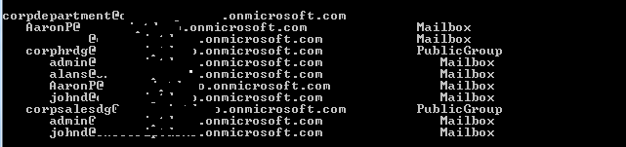

We can also find the file as shown below:

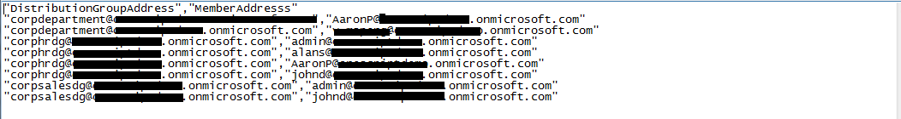

## Using the Code

1. Get the distribution group address

The user needs to input the distribution group address, and we will check if the address is a valid address.

|  |
| --- |
| -Code block start-  --C# code snippet start--  private static String GetGroupAddress()  {  String pattern = @"\w+([-+.]\w+)*@\w+([-.]\w+)*\.\w+([-.]\w+)*";  Regex regex = new Regex(pattern);  do  {  Console.Write("Please input the Distribution Group Address:");  String address = Console.ReadLine();  if (regex.IsMatch(address))  {  return address;  }  Console.WriteLine("The Email address is invaild.");  } while (true);  }  --C# code snippet end--  --VB code snippet start--  Private Shared Function GetGroupAddress() As String  Dim pattern As String = "\w+([-+.]\w+)*@\w+([-.]\w+)*\.\w+([-.]\w+)*"  Dim regex As New Regex(pattern)  Do  Console.Write("Please input the Distribution Group Address:")  Dim address As String = Console.ReadLine()  If regex.IsMatch(address) Then  Return address  End If  Console.WriteLine("The Email address is invaild.")  Loop While True  End Function  --VB code snippet end--  -Code block end- |

2. Process recursively

If the user needs recursion, and the member is group, we will process the method recursively.

|  |
| --- |
| -Code block start-  --C# code snippet start--  if (isRecursive & (member.MailboxType == MailboxType.ContactGroup ||  member.MailboxType == MailboxType.PublicGroup))  {  Console.WriteLine(pad + "{0,-50}{1,-11}", member.Address, member.MailboxType);  ExportGroup(service, member, pad, isRecursive, writer);  }  --C# code snippet end--  --VB code snippet start--  If isRecursive And (member.MailboxType = MailboxType.ContactGroup OrElse  member.MailboxType = MailboxType.PublicGroup) Then  Console.WriteLine(pad & "{0,-50}{1,-11}", member.Address, member.MailboxType)  ExportGroup(service, member, pad, isRecursive, writer)  --VB code snippet end--  -Code block end- |

3. Export the members

If the user sets recursion, the method will export the mailbox addresses of the root group and the nested groups; or the method will export the mailbox and group addresses of the root group.

|  |
| --- |
| -Code block start-  --C# code snippet start--  else  {  Console.WriteLine(pad + "{0,-50}{1,-11}", member.Address, member.MailboxType);  writer.WriteLine("\"{0}\",\"{1}\"", groupAddress, member.Address);  }  --C# code snippet end--  --VB code snippet start--  Console.WriteLine(pad & "{0,-50}{1,-11}", member.Address, member.MailboxType)  writer.WriteLine("""{0}"",""{1}""", groupAddress, member.Address)  --VB code snippet end--  -Code block end- |

## More Information

[EWS Managed API 2.0](http://msdn.microsoft.com/en-us/library/dd633709(v=exchg.80).aspx)

[Expanding a distribution list by using the EWS Managed API](http://msdn.microsoft.com/en-us/library/hh532557(v=exchg.80).aspx)